*.*

**4.1.7 Summary of Organizational Analysis**

*(NO outline needed)*

**4.2 Analysis of Firm Resources and Capabilities***(Person responsible: _______)*

**4.2.1 Tangible Resources**

Table 4.1 of page 68 of our textbook describes four common types of tangible resources. Follow that typology to respond the following topics/questions:

**1a) List the Company’s physical resources (with numbers or other measures) that fall in this category**

Efficient human resources

Wide distribution network

Wide product offering

Massive financial resources

**2a) Compare the Company’s physical resources with several major companies in the same industry**

The company pales in comparison to the main market leaders in terms of the finances. It still lags behind and needs to build a solid financial background first. However, it has done a splendid job in designing the best distribution network that reaches out to a wide network than any other operator in the market. In addition, the employees are also fully qualified and are the reson why the company continues to enjoy massive success.

**3a) Based on above analysis, are the Company’s physical resources “strong”, “moderate”, or “weak” (or terms like “moderate and improving” or “strong but declining”) compared with major competitors in the industry?**

The company’s resources are strong and improving. From the analysis, it is clear that it is only the financial resources are holding back the company. It is up against operators with deep pockets. The company simply needs to build up its asset base for the future situation. It could even explore additional ways to increase its financial base like floating shares or soliciting loans.

**4a) List your references regarding the Company’s physical resources here.**

Bertoldi, B., Giachino, C., Bernard, S., & Prudenza, V. (2015). Fiat-chrysler deal: Looking for a good returns from M & A. *The Journal of Business Strategy, 36*(4), 23-33.

Túry, G. (2018). CONSEQUENCES OF TECHNOLOGICAL CHANGES IN THE AUTOMOTIVE INDUSTRY – PERSPECTIVES OF THE CENTRAL EUROPEAN REGION AS PART OF THE GLOBAL VALUE CHAINS 1. *Global Economic Observer, 6*(2), 82-94.

**1b) List the Company’s financial resources (with numbers or other measures) that fall in this category**

Revenues

Profits

**2b) Compare the Company’s financial resources with several major companies in the same industry**

The company’s revenues have been on an upward trend signaling increasing level of profitability. All this is a result of the strong economic performance and deceasing oil prices both which have boosted the demand level. In fact, the company remains the third most profitable entity.

**3b) Based on above analysis, are the Company’s financial resources “strong”, “moderate”, or “weak” (or terms like “moderate and improving” or “strong but declining”) compared with major competitors in the industry?**

The financial resources are moderate but could possibly take a turn for the better. The recent market developments show the demand level to be increasing. All signs are clear that the market will soon experience a boom. All that remains is for the company to assemble an effective strategy to capitalize on the emerging opportunities.

**4b) List your references regarding the Company’s financial resources here.**

Muto, M., Takebuchi, S., & Amasaka, K. (2013). Creating A new automotive exterior design approach model: The relationship between form and body color qualities. *Journal of Business Case Studies (Online), 9*(5), 367

Lee, S. M., & Lee, S. K. (2014). Objective evaluation of human perception of automotive sound based on physiological signal of human brain. *International Journal of Automotive Technology, 15*(2), 273-282.

**1c) List the Company’s technological assets (with numbers or other measures) that fall in this category, such as patents, copyrights, superior production technologies, or other technologies adopted in their operations.**

Automated operations

Paperless transaction

Company website

Digital marketing

**2c) Compare the Company’s technological assets with several major companies in the same industry**

In matters technology, all companies are the similar. They all have the latest automated processes aimed at increasing the level of efficiency. As a result, there is no outright market leader in this regard. All seem to be intent on maintaining their competitive advantages and will do so through any means possible. So far, it is the technology aspect that has bestowed such opportunities on the main operators.

**3c) Based on above analysis, are the Company’s technological assets “strong”, “moderate”, or “weak” (or terms like “moderate and improving” or “strong but declining”) compared with major competitors in the industry?**

The company’s technology assets might be of high quality but they are inconsequential. This is because all the operators possess similar attributes and innovations. Therefore, efforts to seek any upper hand will be in futility since all operators have the same mindset. They keep matching the strategies of the competitors.

**4c) List your references regarding the Company’s technological assets here.**

Taylor-West, P., & Saker, J. (2012). Computer assisted sales processes in automotive retailing. *International Journal of Retail & Distribution Management, 40*(7), 493-509.

**1d) List the Company’s organizational resources (with numbers or other measures) that fall in this category, such as IT systems, quality control systems, or distribution and retail networks.**

Human resources

IT Systems

Retail and distribution

Financial resources

**2d) Compare the Company’s organizational resources with several major companies in the same industry**

In terms of human resources, the company performs better than competitors. It seems to award priority to the training of employees. All its employees are well qualified and often post high scores in terms of productivity. In terms of IT Systems, the company has moderate advantages since all competitors possess almost similar innovations. It will prove to be impossible to emerge on top in terms of technology among other related aspects. Coming to distribution and retail, Group 1 Automotive has the best retail network in the market. It has a diverse and expansive distribution network with reach across the nation. It would be the most defining asset for the company by the simple fact that it can reach out to numerous customers in comparison to competitors. Finally, financial resources seem to be the company’s Achilles heel. It pales in comparison to well funded competitors which also happen to be the market leaders. The company has to take its time to steadily grow its market capitalization.

**3d) Based on above analysis, are the Company’s organizational resources “strong”, “moderate”, or “weak” (or terms like “moderate and improving” or “strong but declining”) compared with major competitors in the industry?**

From the above analysis, the company’s resources are moderate but improving. So far, it only lags behind financially. Otherwise, its ascent to the top will be unstoppable once it acquires financial muscles to go against the major players in the industry. The distribution will be the main resources for this car dealer. It will have the resources to reach out to its customers much easier than competitors. In terms of technology, it would be better if it kept looking for possible emerging innovations that could provide it with additional competitive advantage.

**4d) List your references regarding the Company’s organizational resources here.**

Jurejevcic, T. (2016). Escalation practices in automotive development. *RUO.Revija Za Univerzalno Odlicnost, 5*(4), 319-331.

Kato, T., Nunes, B., & Dey, P. K. (2016). Is keiretsu really a source of competitive advantage for japanese automotive suppliers? *Journal of Manufacturing Technology Management, 27*(1), 62-81.

**4.2.2 Intangible Resources**

**Table 4.1 of page 68 of our textbook describes four common types of intangible resources. Follow that typology to respond the following topics/questions:**

**1a) List the Company’s human assets and intellectual capital (with numbers or other measures) that fall in this category, such as quality of workforce, talented employees in key areas, learning and training programs, or proven managerial knowhow.**

Skilled workforce

Effective training program

Managerial expertise

**2a) Compare the Company’s human assets and intellectual capital with several major companies in the same industry**

Human assets remain to be the best at Group 1 Automotive. The company is always undertaking training and development at its premises and it comes not as a surprise. A majority of the competitors prefer to have short term employees. To them this strategy works perfectly fine since it helps to save costs. They always hire workers for the short term whenever needs arises. On the other hand, Group 1 Automotive has a different approach altogether. It prefers to train the human capital then retain these over an extended duration.

**3a) Are the Company’s human assets and intellectual capital “strong”, “moderate”, or “weak” (or terms like “moderateand improving” or “strong but declining”) compared with major competitors in the industry?**

The company is always undertaking training and development at its premises and hence we would consider it as a Strong human assets and intellectual capital compared to other **competitors in the industry.**

**4a) List your references regarding the Company’s human assets and intellectual capital here.**

Min, S., & Song, W. (2017). Customer scope and supplier performance: The japanese automotive industry. *Annals of Business Administrative Science, 16*(4), 165-176.

**1b) List the Company’s brand, image, and reputational assets (with numbers or other measures) that fall in this category, such as brand reputation and awareness ranking by third party and trade associations, buyer loyalty, superior services, or reputation for product quality.**

Brand equity

Differentiation

Customer loyalty

**2b) Compare the Company’s brand, image, and reputational assets with several major companies in the same industry**

The car dealership industry display oligopoly tendencies where few major operators dominate the sector. This is exactly what is happening in the industry since Group 1 Automotive competes with a handful operators. The issue is that the business requires massive capital injection which is often beyond the reach of many entrepreneurs. In addition, the heavy financial resources are necessary to maintain high brand equity like Group 1 Automotive has done. It boasts one of the top brands in the market and is the reason why it has recorded monumental success. The only issue is that competitors also possess strong brands which can influence customer purchase decisions.

**3b) Are the Company’s brand, image, and reputational assets “strong”, “moderate”, or “weak” (or terms like “moderate and improving” or “strong but declining”) compared with major competitors in the industry?**

Group 1 Automotive enjoys one of the strongest brands in the market. It has made inroads into the market by simply leveraging its strong brand. Consequently, the company enjoys high customer loyalty as a result of the trust. The customers believe it is the go-to company whenever they have automotive-related needs. Its brand equity is very strong and will be critical in determining the level of success in the near future. The company simply needs to keep up this good work to solidify its position in the market.

**4b) List your references regarding the Company’s brand, image, and reputational assets**

Túry, G. (2017). GLOBAL OR MORE REGIONAL? ANALYSIS OF GLOBAL EMBEDDEDNESS OF THE CENTRAL EUROPEAN'S AUTOMOTIVE INDUSTRY VIA VOLKSWAGEN GROUP'S INTRA-FIRM LINKAGES 1. *Unia Europejska.Pl, 245*(4), 3-13.

**1c) List the Company’s relationship resources (with numbers or other measures) that fall in this category, such as**

Partnerships

Intense rivalry

**2c) Compare the Company’s relationship resources with several major companies in the same industry**

The company has made efforts to secure partnerships with almost every major car manufacturer. It understands as a car dealership, it will have to stock a wide range of vehicle due to its diversified clientele. This is why customers will never lack options at the premises at any given instance. The company is always on standby to meet the customer needs. However, there is intense rivalry with other car dealerships in the market. The tense relationship is all about each trying to outdo the other. The competition will only become more intense with the recent market development where each operator desires to clinch the market leadership position.

**3c) Are the Company’s relationship resources “strong”, “moderate”, or “weak” (or terms like “moderate** **andimproving” or “strong but declining”) compared with major competitors in the industry?**

The company’s relationships with the supplier are strong in the sense that they have formed working partnerships. The car manufacturers simply concentrate on the production while leaving the selling to the dealerships. This effective working relationship has enabled each to undertake their work diligently. It is no wonder there are seamless operations in this market.

**4c) List your references regarding the Company’s relationship resources here**

Swarnakar, V., & Vinodh, S. (2016). Deploying lean six sigma framework in an automotive component manufacturing organization. *International Journal of Lean Six Sigma, 7*(3), 267-293. doi:http://dx.doi.org.contentproxy.phoenix.edu/10.1108/IJLSS-06-2015-0023

**1d) describe the Company’s culture with balanced views and also refer to Section 4.1.4 (but you should discuss more briefly here).**

The company has a traditional and conservative culture aimed at providing the highest levels of customer satisfaction. It tailors its service towards meeting customer needs better than any of its closest rivals in the market. As a result, it boasts very high levels of customer satisfaction.

**2d) Compare the Company’s culture with several major companies in the same industry to justify your judgment in 1a)**

The two other major market leaders prefer to focus on building capacity. To them, they are fully intent on benefiting from the economies of scale. Their motive is amalgamating the operations of smaller operators to build upon theirs. This is how they have managed to accumulate massive operations in the car dealership industry. Their aggressive stance has been very beneficial in keep ing competitors at bay. They literally obliterate any possible threat through mergers and acquisition.

**3d) Are the Company’s culture“strong and productive”, “weak”, or “strong and counterproductive” (or similar descriptive terms) compared with major competitors in the industry?**

The company’s culture is strong and productive. Having opted to settle on customers as the focus of the culture, it has been smooth sailing for the organization. It now keeps building upon this by constantly redesigning its culture and strategy. What is more, customers seem to enjoy this culture. In fact, so much effective has it been that competitors are now opting to emulate the same. In the recent past, several competitors have opted to make customers the epicenter of their operations. This is in stark contrast to the situation where they previously went for economies of scale. This is only evident that customer-oriented culture is the way to go in the future.

**4d) List your references regarding the Company’s human assets and intellectual capital here.**

Neto, M., Matui, P. C., Candido, S. E. A., & do Amaral, R. M. (2016). Relational structure in the global automotive industry: Groups, networks and fields. *Revista Brasileira De Gestão De Negócios, 18*(62), 505-524.

**4.2.3 Capabilities**

**The following table describes seven common types of capabilities. Follow that typology to analyze each of them following the same sequence and requirement as that in the previous section (4.2.2). Please use bullet points for your arguments. Keep in mind for each of these capabilities you need to 1) describe/analyze the capability, 2) compare it with industry peers, and 3) give your judgment (strong, moderate, weak, etc). Lastly you need to provide any references that help you to conduct the analysis.**

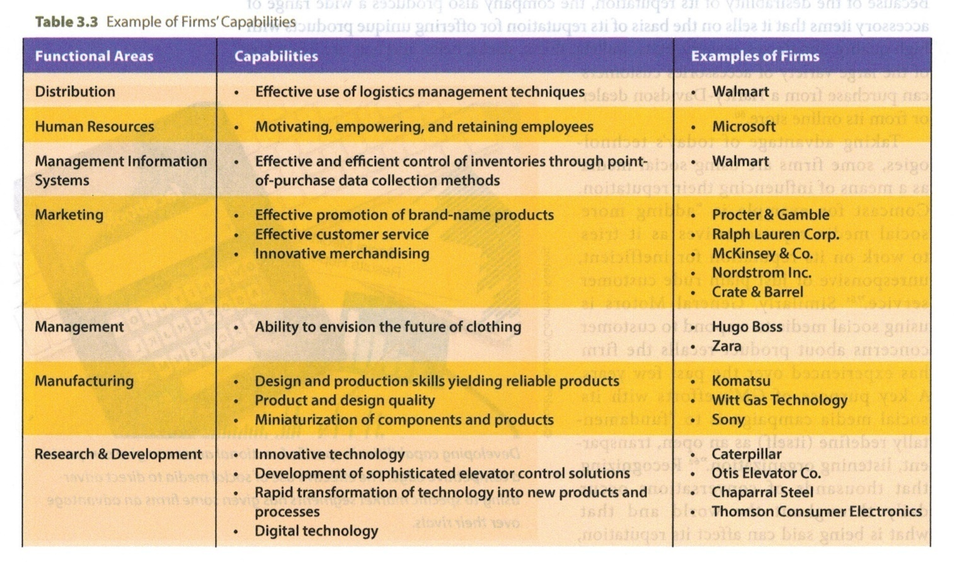

* **Logistic management techniques**

The company has an efficient distribution network which handles the logistics across the nation. Its logistics constitutes some of the core competencies at the company. In relation to competitors, there is very little to write home about. All competitors have made arrangements to establish efficient logistical infrastructure. In any case, they all deal in the distribution and sale of automobile across the nation. Therefore, this factor cancels out for all stakeholders. The capability is moderate and will contribute very little to the future success at Group 1 Automotive. It all boils down to the advantages the capability or resource brings to an entity.

* **Motivating and training employees**

Employees are the most critical resources in an organization. In the case of Group 1 Automotive, it has gone out of its way to constitute an effective workforce. It offers some of the best remuneration packages which other companies can only dream about. This has led to a higher rate of employee retention at the facility. Not many organizations can accomplish such a feat especially with a massive and diverse workforce like the one at Group 1 Automotive. This capability is strong and will contribute immensely to the success at the company in the near future.

* **Brand promotion**

Brand equity is another area Group 1 Automotive has struggled to keep up with the main market leaders. Despite the popularity of its brand, it is not a secret that it is the third strongest in the market. Customers will always seek to rely on the services of the most popular operator. In this case, sadly it is not Group 1 Automotive. It will have to play catch up to the main market leaders. The capability is weak and needs to receive priority in the coming years. The management should seriously consider rejuvenating this brand to compete with the main players.

* **Accurate future forecasting**

In terms of accurate forecasting, Group 1 Automotive performs very well. The company has accurately read the signs in the market and proceeded to assemble a winning mix of resources. For instance, international diversification remains to be its greatest move to date. With this strategy, it has succeeded in locking out the main competitors from emerging markets with specific reference to Brazil in Latin America. This is a very strong capability and will provide the launching pad for its international operations mainly in developing world in the future.

* **Efficient manufacturing**

Sadly, Group 1 Automotive is not in the manufacturing business. All it does is to distribute ready made vehicles. Perhaps its repair services could come close to this but still does not constitute manufacturing. Therefore, the company and industry in general will remain exempted from this capability.

* **Research and development**

This is one area Group 1 Automotive has performed splendidly. The company has made efforts to understand its core customers. It does not just stock vehicles in its yards haphazardly. Rather, it makes accurate research findings on which are the most popular vehicle brands. The only downside to this strategy is that the rivals also tend to do the same. In fact, they imitate one another in terms of stocking the fastest moving brands. Therefore, this is one area which comes with very high degrees unpredictability. It is suffice to say that the competitors remain at par on this front.

**4.2.4 Core Competencies and Sustainable Advantages** *(Person responsible: _______)*

**1) Use one sentence to summarize the definition of “core competencies”.**

Core competencies denote the attributes that make an organization unique and which also contribute towards its success.

**2) Among all the resources and capabilities, you analyzed in previous two sections, what do you think are the core competencies of Group 1 Automotive according to the definition of core competencies? Briefly give your justification.**

Upon a careful analysis, Group 1 Automotive has been riding high on efficient human resource practices and fairly strong brand equity. The human resources have been critical in ensuring the company enjoys skillful workforce in relation to competitors. In this industry, the operators sell similar car models and success boils down to the effectiveness of the sales personnel. Therefore, it comes not as a surprise that Group 1 Automotive enjoys high revenues with such a skillful workforce. The employees are well qualified to convince customers to purchase models suiting their needs and those that are also within their budgets. The brand also plays a critical role in the success of the company. In this industry, as mentioned, operators have similar standardized products. Therefore, it will take great efforts to try and outdo a well established competitor with a strong brand. Naturally, the customers will gravitate towards the operator with the strongest brand. Group 1 Automotive boasts one of the top three brands in the market and its success is attributable to this factor.

4.2.5 Value Chain Analysis(Person responsible: _______)

1) Draw a figure/table (with simple descriptions) for the industry value chain (following the textbook and/or sample paper). Make your terms/descriptions specific to our industry.

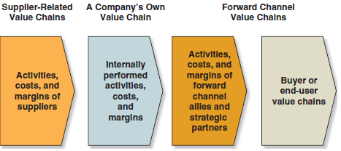

Source: Based in part on the single-industry value chain displayed in Michael E. Porter, *Competitive Advantage* (New York: Free Press, 1985), p. 35.

2) Draw a figure/table (with simple descriptions) for Group 1 Automotive’s value chain (following the textbook and/or sample paper). Make your terms/descriptions specific to the Company.

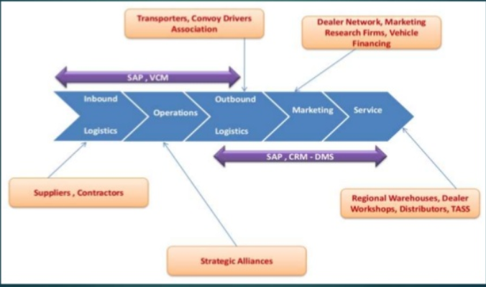

3) Do you think the Company’s various activities in its value chain are consistent with each other and aligned with the Company’s strategy and positioning?

Human assets remain to be the best at Group 1 Automotive. The company is always undertaking training and development at its premises and it comes not as a surprise. They prefer to train the team members and retain them for long duration of time. So by this we can say that Company’s various activities in its value chain like operations, marketing, and services do need the manpower as they are involved in strategic alliance, transportations, dealer network etc. Hence we can say that Company’s various activities in its value chain are consistent with each other and aligned with the Company’s strategy and positioning?

**List your references here.**

Dillard,John E.,,Jr, & Bates, D. L. (2010). MANAGING SATISFACTION IN THE AUTOMOTIVE INDUSTRY: THE ECONOMICS OF SAVING EXPECTED DEFECTORS. *Journal of Consumer Satisfaction, Dissatisfaction and Complaining Behavior, 23*, 83-94.